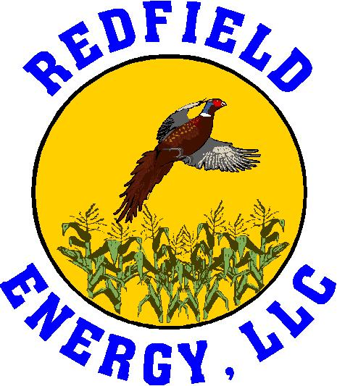
Job Description
Commodity Handler

Reports To: Commodity Supervisor
FLSA Status: Non-Exempt
Department: Commodities
Summary

The Commodity Handler is responsible for loading dried distillers grains, ethanol, and wet cake feed trucks and rail cars. Team members in this position use mechanical equipment, meters, or scales as well as computers and software equipment when loading products to ensure a timely delivery and product safety. Team members must be able to work mandatory overtime when outside their regularly scheduled shift when directed by management.
Essential Functions

- Load trucks and rail cars with feed and fuel products of Redfield Energy using mechanical equipment, meters and scales as required to ensure timely delivery of products.
- Operate large machinery and equipment.
- Maintain a clean work area.
- Enter bins adhering to Redfield Energy’s confined space procedures.
- Complete HAZMAT paperwork when necessary.
- Learn, maintain and operate all processes associated with the commodities operation including repair and maintenance.
- Remove, install, rebuild, lubricate and clean all equipment associated with the commodities process.
- Perform preventative maintenance tasks as directed.
- Must be able to meet call-in requirements as well as work extended hours as necessary.
- Perform all tasks associated with Feed Safety/Quality, assigned or as needed, to meet internal and external requirements relating to the production of safe, quality feed products.
- Foster a culture of safe behavior and environmental compliance at all times.
- Work in an honest and ethical manner; maintain confidentiality on all business related matters.
- Team member is expected to physically report to work on time at their assigned location and is seldom absent.
- Team member can be depended upon to complete work in a timely, accurate and thorough manner and is conscientious about assignments.
- Maintain a team environment with other departments at all times.
- Champion Redfield Energy in the community.
- Maintain a high level of customer service and friendly atmosphere.
- Other duties as assigned.

Education & Experience Requirements/Competencies

To perform the essential functions of this position successfully, an individual should be able to demonstrate and provide the following:
- High school diploma or equivalent preferred but not required.
- Experience in truck loading and unloading, including rail tank car and tanker truck preferred.
- Forklift and skid loader certification preferred; valid driver’s license with proof of insurance required.
- Basic computer knowledge and willingness to learn new software applications and Word, Excel and Outlook.
- Excellent organizational skills, communications skills, the ability to multi-task, and most importantly, the ability to work well in a team environment.
Work Environment/Physical Requirements

This position is largely self-directed and requires a thorough understanding of company policy, procedures and values. Team members will be required to adhere to safety requirements at all times and in all work environments. This position operates in both an office and plant environment. In the office, the team member will work on a personal computer. In the plant environment, the team member may be exposed to noise, heat and other elements both inside and outside as well as possible exposure to moving, mechanical parts, dust, high noise levels, internal and external temperature/weather conditions and exposure to chemicals.

Specific physical requirements include:
- Occasionally lifting weight up to fifty (50) pounds.
- Climbing several flights of stairs and ladders.
- Opening valves.
- Occasionally bending, twisting and turning while lifting weight of less than fifty (50) pounds.
- Data entry while seated for greater than one (1) hour.
- Walking up to two (2) or more miles per day.
- Pushing brooms, shovels, etc.
- Working at heights, in confined spaces and at temperatures from -20 to +100 degrees.
- Standing for extended periods of time.
- Wearing PPE.
- Using hand and power tools.
- Ability to crawl under, on top of and around rail cars.

